**WORD OPERATION TOOL**

**USER GUİDE**

Halil Uğur BAYEZİT

CS-TECH Candidate Evaluation Exam

**CONTENTS**

**1. SUMMARY ………………………………………………………………………... 1**

**2. TECHNİCAL REQUIREMENTS………………………………………………... 1**

**3. INSTALLATION INFORMATION……………………………………………… 2**

**4. PROGRAM USAGE……………………………………………………………….. 2**

**1. SUMMARY**

With the Word Operation Tool Program; By determining a word from the text in a file selected by the users, certain commands (F, D, R) are used to find this word in the text, replace it with another word and delete it. While the selected word can be found alone in the text, it is also possible to find other words in the word by using the symbols '' - '' and '*'. When the “-” symbol is used, the software replaces all the letters of the alphabet in the position where”–“ is located, while showing all the words that can occur; When the symbol “* “ is used, words with zero or more letters are shown depending on the position of the “ * “. For example: Assuming that the word “alı” is selected, the program can find the word “balık” when the F -alı-, F *alı* can find the Word “salıncak” when the given command. This rule also applies to the Delete and Replace commands.

Program; perform to facilitate, facilitate, prevent loss of effort and provide to save time.

**2. TECHNICAL REQUIREMENTS**

Since the program is a C ++ file, it runs smoothly on any platform that can run the C ++ file (For example: Dev-C ++, Visual Studio Code, Code :: Blocks etc.).

**Warning!**

The program has been prepared using C ++ 11. The steps to add C ++ 11 to Dev-C ++ platform are as follows:

1- Settings 🡪 Compiler Settings

2- Programs-🡪gcc & g ++ ->. Can be used as c ++ 11 after adding -std = c ++ 11 after exe. (Figure1)

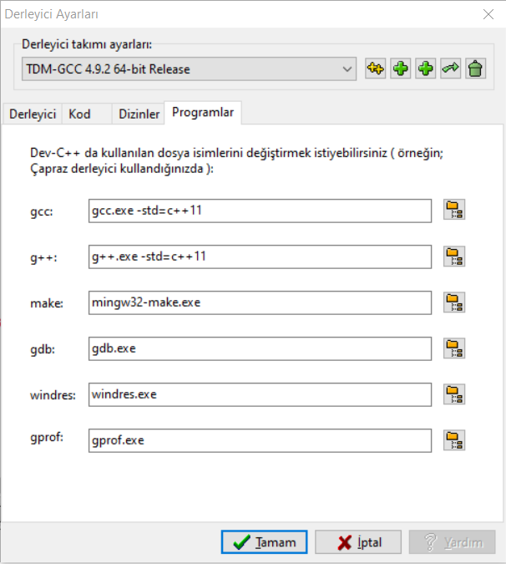

**Figure 1.**

**3. INSTALLATION INFORMATION**

After the source codes shared via GitHub are downloaded to the computer, they are opened with the appropriate program on the computer and started to be used.

Source codes can be found at the following address:

<https://github.com/ugurbayezit/Word-Operation-Tool>

**4. PROGRAM USE**

After the source codes are downloaded and run on the platform used, the user will be asked to select the file by giving the location of the file that he wants to process on the computer (Figure 2). In the next step, a selection screen appears for the user to select the action he wants to do on this file. There are Find (F), Replace and Delete options on the screen (Figure 3). During the Find (F) process, the desired word input from the user is expected (Figure 4). At this stage, the user can search for the word he wants to find in 3 different ways. For example, the word '' a '' can be searched as '' a '', '' * a * '' or '' -a ''. However, the user cannot use more than 2 '' * '' or 2 '-' symbols. The use of '' * '' and '‘-' symbols in the same word is prevented (Figure 5). The results obtained after this search return to the user (Figure 6). The same procedure and rules are valid for Replace and Delete operations (Figure 7 & 8).

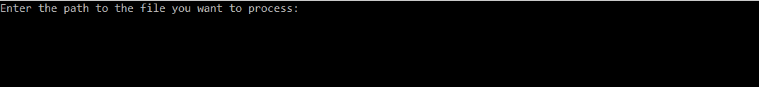

**Figure 2**



**Figure 3**

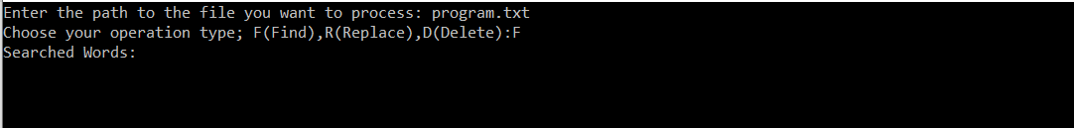

**Figure 4**

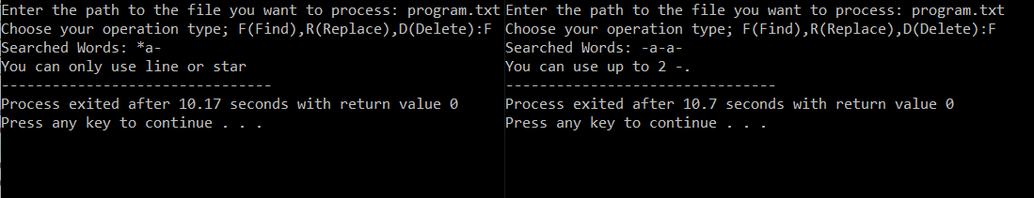

**Figure 5**

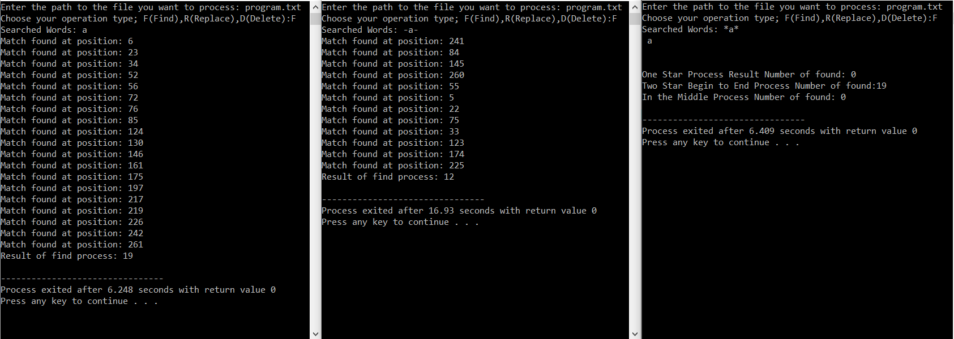

**Figure 6**

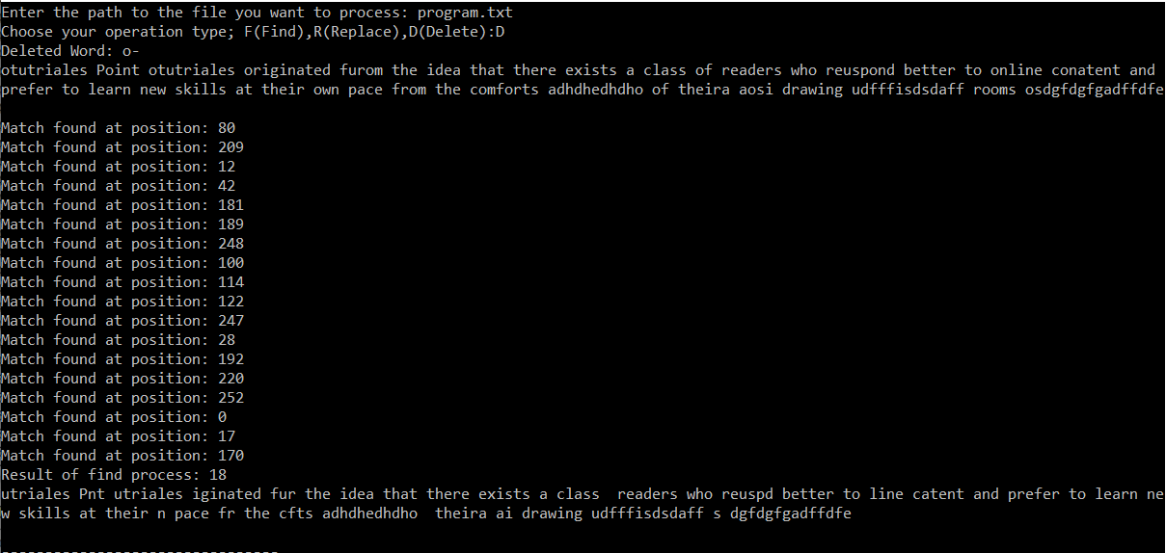

**Figure 7**

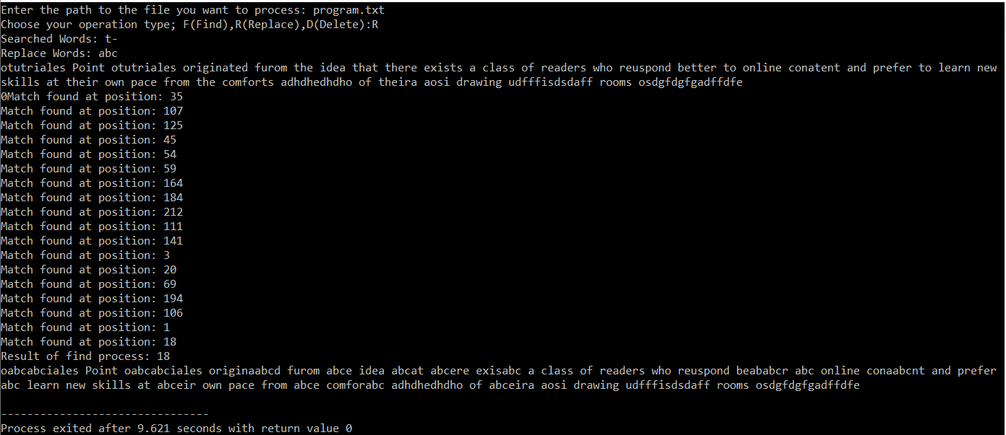

**Figure 8**